Assignment 18: RADIUS & TACACS+
Student Name | Shreya Panchal
Topic | TACACS+ & RADIUS Features, RADIUS Authentication Process, TACACS+ Use Cases, RADIUS vs. TACACS+

Theory Overview

1. RADIUS (Remote Authentication Dial-In User Service)
RADIUS is an open standard, UDP-based protocol designed primarily for network access control. It combines authentication and authorization into a single profile response while keeping accounting separate. It is highly optimized for scenarios with thousands of distributed end-users connecting to a network, such as ISP dial-ins, corporate Wi-Fi authentication, or public hotspots.

2. TACACS+ (Terminal Access Controller Access-Control System Plus)
TACACS+ is a Cisco-developed architecture (later made open) designed primarily for device administration. It runs over TCP, ensuring reliable delivery of packets. Unlike RADIUS, TACACS+ strictly separates all three AAA elements — Authentication, Authorization, and Accounting — into independent processes. This makes it granular enough to control exact CLI command privileges for engineers logging into infrastructure hardware.

Tasks & Answers

Task 1: RADIUS vs. TACACS+ Comparison Table
Create a comparison table listing at least 4 key differences between RADIUS and TACACS+ features, focusing on protocol type, encryption, ports used, and command authorization.
Answer:
Feature | RADIUS | TACACS+
Protocol / Transport Layer | Uses UDP (connectionless, lightweight, and fast). | Uses TCP (connection-oriented, reliable, and error-checked).
Encryption Type | Encrypts only the password inside the packet. The rest of the payload (username, attributes) is visible in cleartext. | Encrypts the entire body of the packet, ensuring maximum confidentiality of usernames and operations.
Ports Used | Uses standard UDP ports 1812 (Auth) and 1813 (Accounting) [or legacy ports 1645/1646]. | Uses standard TCP port 49.
Command Authorization | Poor / low capability. Authorization attributes are bundled together with the initial authentication response. | Excellent / highly granular. Can validate individual CLI commands entered by an admin on a per-user session level.

Task 2: RADIUS Authentication Process Diagram
Draw a simple flowchart or sequence diagram that illustrates the RADIUS authentication process for a user trying to log in to a Wi-Fi network (like at a coffee shop or college campus).
Answer:
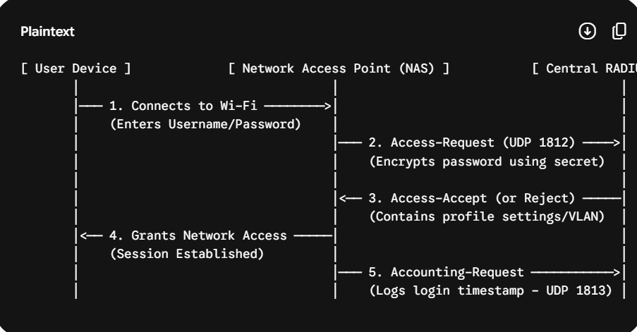

Task 3: Real-World Scenario: TACACS+ for Admin Access Management
Describe a real-world scenario from any app you use (such as Zomato, Paytm, or IRCTC) where TACACS+ would be more suitable than RADIUS for managing admin access, and explain why.
Answer:
Consider the backend operations of a massive financial application like Paytm. While RADIUS is great for regular customers logging into their apps, TACACS+ is the standard mechanism deployed to manage internal network engineers who look after Paytm's core database routers and switches.
If a junior network engineer logs into a core payment gateway switch via SSH, the company needs to ensure they can execute harmless inspection tasks (like show running-config) but are strictly blocked from breaking things via destructive commands (like reload or erase startup-config). TACACS+ is ideal here because it separates authorization completely, forcing the switch to check the corporate server on every single keyword the technician types. Furthermore, TACACS+ encrypts the entire command stream, safeguarding infrastructure passwords from sniffing threats inside the backend data center.

Task 4: Advantages & Disadvantages of RADIUS in Public Hotspots
List two advantages and two disadvantages of using RADIUS for network authentication in a public hotspot (like those found in malls or airports).
Answer:
Advantages:
- High Scalability & Performance: Because it is powered by stateless UDP, a single core RADIUS engine can process connection/disconnection notifications from thousands of roaming clients simultaneously without lagging or crashing.
- Universal Vendor Compatibility: It is standard across all networking systems, meaning an airport can combine Cisco, Aruba, or Ubiquiti hardware with the same open backend user database.
Disadvantages:
- Partial Packet Encryption: Since it only secures the password field, cleartext usernames are broadcast during the exchange phase, making it easier for eavesdroppers to harvest phone numbers or registration metrics.
- No Session Verification (UDP Lack of ACK): Since UDP does not require connection verification, if a network node drops packets, the server might not realize an end-user timed out, leading to mismatched active session logs.

Task 5: Basic Cisco Router TACACS+ Configuration
Use ChatGPT or another AI tool to generate a sample TACACS+ configuration for a Cisco router, then review the output and highlight any commands you would modify for a college lab setup. Hint: Ask the AI tool for 'basic TACACS+ configuration for Cisco router' and check for lines like 'tacacs-server host' and 'aaa new-model'.
Answer:
Generated Basic Configuration:
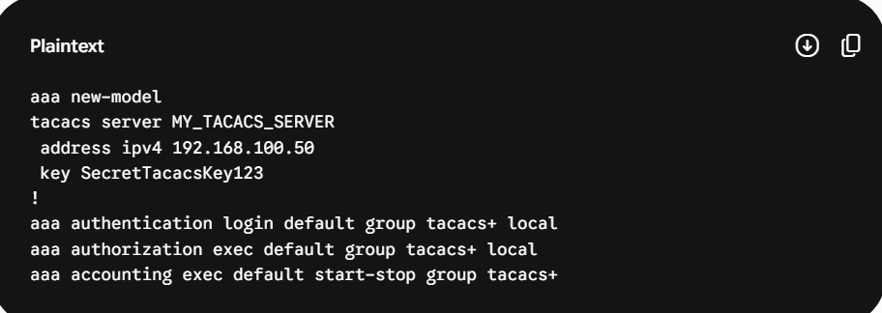
Review and Modifications for a College Lab Setup: To deploy this configuration within a physical college laboratory router, a few parameters need adjustment to prevent students from locking themselves out of the devices:
